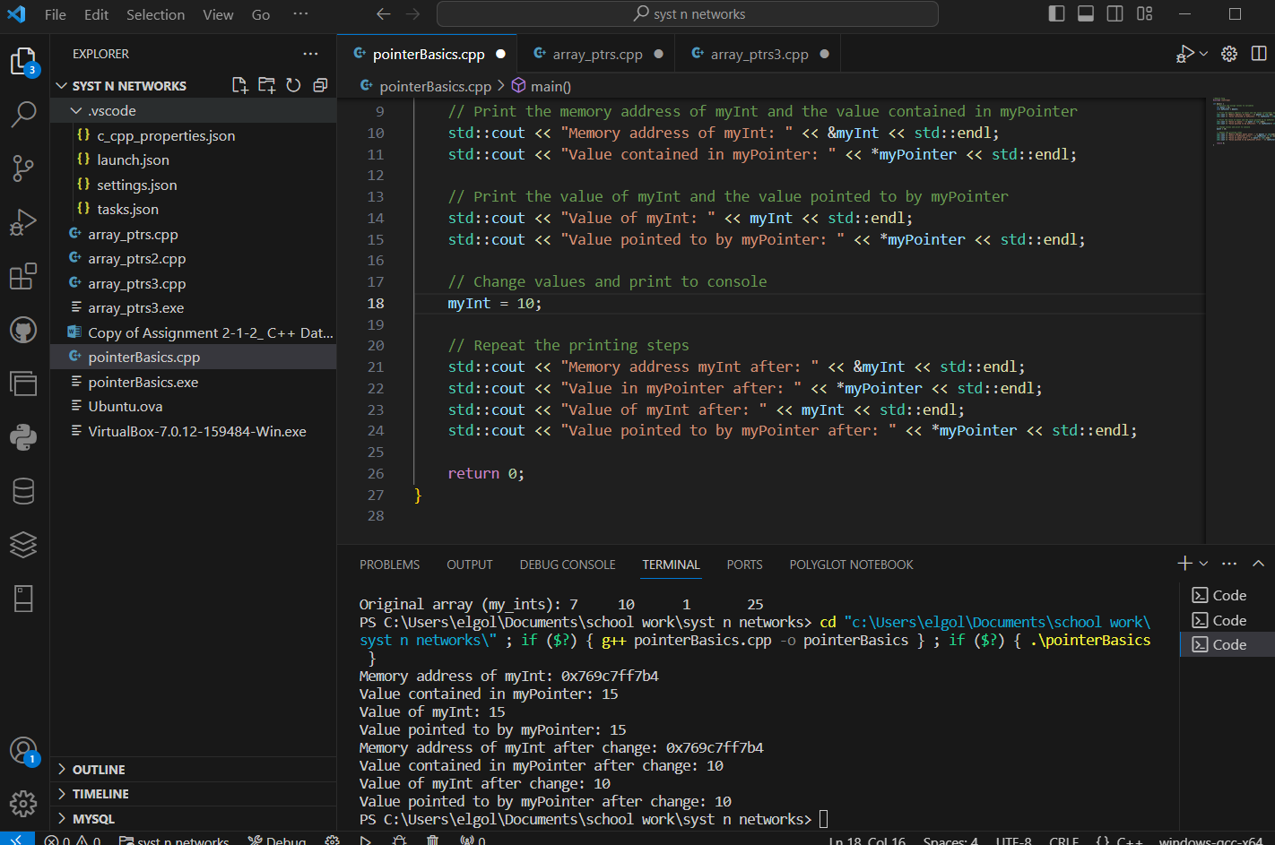

Would give me win main error so i compiled it in my vscode environment

My second code would not work in the virtual machine so i ran it in my vscode environment

